Task 4
Basic Rule-Based Chatbot
Objective
The objective of this project is to develop a simple rule-based chatbot using Python. The chatbot interacts with the user through the console and provides predefined responses to common messages such as "hello", "how are you", and "bye". This project helps understand basic Python programming concepts including functions, loops, conditional statements, and input/output operations.
How the Chatbot Works
- The program starts by displaying a welcome message.
- The chatbot asks the user to enter a message.
- The entered message is converted to lowercase for easy comparison.
- The program checks the message using if-elif-else conditions.
- For "hello", the chatbot replies "Hi!".
- For "how are you", the chatbot replies "I'm fine, thanks!".
- For "bye", the chatbot replies "Goodbye!" and stops the loop.
- For any unknown message, the chatbot displays an appropriate default response.
Algorithm
1.Start the program.
2.Define the chatbot function.
3.Display the welcome message.
4.Take input from the user.
5.Convert the input to lowercase.
6.Compare the input with predefined messages.
7.Display the corresponding response.
8.If the input is "bye", terminate the loop.
9.Otherwise, continue taking user input.
10.End the program.
Code
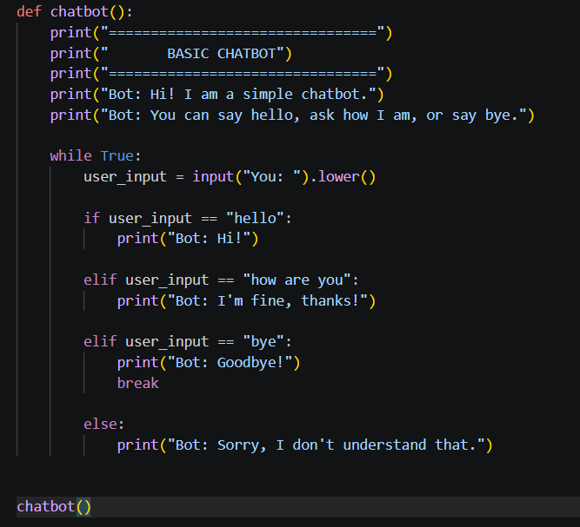
Output :
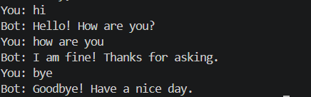

13. Conclusion
The Basic Chatbot project successfully demonstrates how a simple rule-based conversational program can be created using Python. It uses functions, loops, conditional statements, strings, and input/output operations. The project provides a practical introduction to building interactive console applications.

